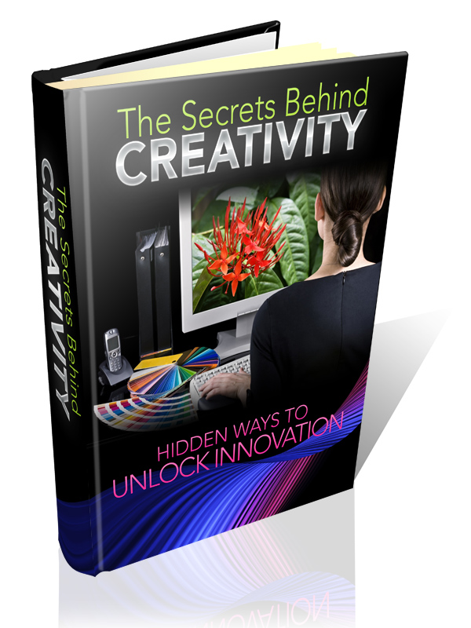

Terms and Conditions

LEGAL NOTICE

The Publisher has strived to be as accurate and complete as possible in the creation of this report, notwithstanding the fact that he does not warrant or represent at any time that the contents within are accurate due to the rapidly changing nature of the Internet.

While all attempts have been made to verify information provided in this publication, the Publisher assumes no responsibility for errors, omissions, or contrary interpretation of the subject matter herein. Any perceived slights of specific persons, peoples, or organizations are unintentional.

In practical advice books, like anything else in life, there are no guarantees of income made. Readers are cautioned to reply on their own judgment about their individual circumstances to act accordingly.

This book is not intended for use as a source of legal, business, accounting or financial advice. All readers are advised to seek services of competent professionals in legal, business, accounting and finance fields.

You are encouraged to print this book for easy reading.

Table Of Contents

Foreword

Chapter 1:
Two Types Of Imagination For Creativity

Chapter 2:
How To Use Creative Imagination

Chapter 3:
About Synthetic Imagination

Chapter 4:
Expand Your Thinking

Chapter 5:
Produce New Ideas

Chapter 6:
Get Rid Of Either/Or Thinking

Chapter 7:
Business Ideas From Competitors

Chapter 8:
How To Keep Track Of Ideas

Chapter 9:
Sometimes You Must Take A Break

Chapter 10:
Get Off Your A** And Do Something

Foreword

What does creativity mean to you? To most individuals, they refer to the arts – writing and music for instance. However creativity applies to everything – anything fresh, anything that's never been created earlier, stems from the creative mental faculty.

The Secrets Behind Creativity

Hidden Ways To Unlock Your Innovation

Chapter 1:
Two Types Of Imagination For Creativity

Synopsis

What are your goals, your jobs, and your hobbies? Can you determine how creation plays a role in that? Do you know that there are 2 different kinds of imagination that play a role in creativity?

What Are The 2 Forms Of Imagination?

Creative Imagination
Creative imagination, which lies on the far side of our logical mind and our ego, is where all genuinely new ideas derive from. When a scientist devises something the globe has never seen before, he's using creative imagination. Consider it as new clay.

Thomas Alva Edison, Alexander Bell, and Elmer Gates were splendid inventors who learned to tap into creative imagination. Mr. Thomas Edison, for instance, was reported as having tested more than ten thousand ideas for his electric-light bulb using his synthetic imagination alone, and they all failed. It was only when he tapped into his creative imagination that he carried off the perfect electric-light bulb.

Synthetic Imagination
What is this synthetic imagination? This is the imagination delivered of education and experience. You apply your mind to alter things around, view them from another angle, or rearrange existing stuff to form something “new”. But nothing really new ever came from synthetic imagination.

How much of what you accomplish has never been witnessed before (by you, at any rate)? When you author a fresh book, are you regrouping stories or legends you’ve seen before, substituting characters, hacking and exchanging? When you write a new musical composition, are you truly only changing one of your preferred childhood songs? When you do a fresh marketing campaign, are you simply placing your own spin on a successful campaign already used by some other company?
Most modern creative thinking books available are in reality centering on your synthetic imagination. But there's nothing inappropriate about this; as a matter of fact it's a critical step. An original idea frequently needs to be forged by education, reasoning, and experience in order to forge a finished product.

Take the design of the cover of this book, for example (hopefully you're reading a legal copy that has the cover). It started out as an original idea in my head, as the new clay of creation. I started to apply my synthetic imagination to forge the clay. As I started to transfer the idea out of my brain into my computer, I used my graphic skills to cut it down to what is conceivable with current technology. I formed the vague idea by adding together colors according to existent color theory. I affected text and pictures into certain positions based on what I know of human computer interaction. It's only then it turns into a finished product.

Let me sidetrack a bit here. All thoughts, all goals, everything we would like to achieve starts out as an idea in our mental realms, and is forged by worldly hands. Anything humankind ever created started out as a thought. Anything humankind ever created was forged by worldly hands.

Now let’s look at applying the 2 forms of imagination.

Chapter 2:
How To Use Creative Imagination

Synopsis

So, how do you use this creative imagination? Let’s take a look.
Brining Forth Creative Imagination

Inventor Gates, bearer of over two hundred patents of invention, used to “sit for ideas”. He sat in his room, sound-proof and with moderated lighting, with pen and paper. Then he mulled over whatever he was working at, as much as he knows of the matter, and awaited ideas in the configuration of inspiration and intuitions to come out, and he started writing them all down.

Initially I supposed it sounded eerie, like some Ouija board, but I recognized this was how many individuals in the creative fields of art, authoring, design, and so forth work, whether they recognize it by name or not.

Allow me to explain more. Inspiration issues forth from beyond the mind, maybe from your subconscious mind. It dashes into the conscious mind when it's ready to receive.

This works still better when the mind is excited. There is a list of 10 stimuli, listed in order of descending potency.

1. Want for intimate expression
2. Love
3. Blazing want of fame, power, or profit
4. Music
5. Friendly relationship
6. A master mind coalition (a group who assists each other achieving goals)
7. Common suffering
8. Self-hypnosis (reiterated affirmations)
9. Fright
10. Narcotics and intoxicants

A few of these are damaging, so its common sense to say don’t utilize them. It’s been included for the interest of completeness. You are able to probably dream up some great ideas you’ve had when drunk, or while you're shaking in your boots.

I likewise recognized this list was how I got my finest inspirations in my own work. For instance, I work best with slow jazz music – it energizes my mind. The still or other types of music annoy me and decelerate my work. It's outside work that I get my finest inspirations, however.

My most successful ideas arrived when I was lying down in bed, almost to float off to sleep, or once I had just awakened. It's long-familiar to hypnotists that your subconscious is most approachable when you're sleeping, going into, or moving out of sleep.

This explains why most originative doers have their own little habits, rituals, or superstitious notions as they work – they require their own sort of stimulants.

While you're sitting for ideas, utilize a journal or something you are able to write on. Keyboards don’t work so easily, you frequently think so quickly your typing fingers can’t follow. You likewise need to draw and doodle occasionally. Put down even the cockeyed ideas. In the next chapter we'll talk about synthetic imagination which lets you make these ideas functional.

Try a couple of the positive stimuli. This will be simple at first, but your ideas will dry out up. The magic is to continue; most of my finest ideas come up after a few days.

Other instruments you are able to try to apply are mind mapping or associative thinking. They're pretty interchangeable. They merely refer to expounding ideas.

Let’s say you require themes for your fiction novel. Put down the name of the chief character and put a circle around it. Then branch off it with as many matters that pop into your head as you are able to. Offset circles may include painfulness, felicity, or even random matters like the moon, or a mint.

Extend each of those circles. Painfulness may link to a different characters name, and then you may think up a dandy storyline involving treason by that character. The moon may lead to a wolfman plotline.

What’s next?

During the research for this book, I accumulated a big pile of creativity tools and thoughts from my own brain and books. I’ve split them up – this chapter covers creative imagination, and the following chapters will be about synthetic imagination and all the ways you can stimulate your innovation and creativity.

Chapter 3:
About Synthetic Imagination

Synopsis

Synthetic imagination is the manipulation of effects. Creative imagination is causal that produces effects.
A Look At The Other Side

All matters, from the invention of writing to the invention of the Net happened because of the practice of creative imagination.

Synthetic imagination simply, at best, can improve upon what already lives.

The adding of fresh things into being requires the use of creative imagination.

The origination of wealth can be incurred, with diligence, through the informed and pragmatic use of synthetic imagination (e.g. creating a better mouse trap), however most wealth and most forward motion in human applied science happens through the use of creative imagination.

Compactly put, your imagination is the workshop in which you, by and large without conscious acknowledgement, create the results that surface in your life.

What you bear as an image in your brain is what turns up in your life.

If what you're imagining is merely a rehash of what has already happened or been produced by other people, then your results shall be limited to what has been, not what can be.

The pitiful, sad, distressing thing that we impose upon our youngsters and ourselves is the stifling of imagination.

'It's only in your imagination'

Is the basic refrain. We neglect telling them or reinforce their personal self help and, help them comprehend, that all great and fantastic things that live in our world, had their genesis 'only in imagination'.

We have explained that there are 2 proficiencies of imagination namely, creative imagination and synthetic imagination. As well, it becomes important and essential to learn just how every aptitude works and know that one is tremendously a component of the right brain hemisphere and one a part of the left brain hemisphere. To be a huge success in the business field or any other arenas, the imagination in centered and focused use is necessary. To be able to capitalize on this extraordinary and particular ability which we all inherently have, we need to comprehend completely, and then heighten our ideas.

As business minded persons, we became so highly skilled and adept in acting from the left side (the analytical, logical) of our brain, that we may be in peril of under using our right side (the artistic, intuitive) part of our brain. That's why scientists today agree that the roles and obligations of the brain can't be merely carved up as left-or right brain. Creative or artistic Imagination. When we get some "inspiration" and "intuitions", it's through the faculties of our creative vision that carry them out. This creative or artistic mental faculty becomes more mentally amenable and alert in relation to its evolution through constant use and practice.

It mechanically works when our conscious mind acts at an extremely fast-moving rate and when it's excited through the feeling or emotion of strong want. By utilizing this creative imagination, leaders and groundbreakers in finance, business, and industry in addition to famous and notable poets, artists, musicians and authors become great and enormously successful. Synthetic Imagination-this specific inborn power of one's mind works with the stuff of observation, experience and training, with which it's being fed. It simply classifies and arranges prior technique and expertise: thoughts, plan or concepts into new and new combinations. It's utilized by many groundbreaking thinkers and inventors whereas the genius draws on the innovativeness on the creative imaginative side where it can't solve problems by the synthetic imagination.

So long ago, we were more intuitive and more effusive, but as we Understand and learned to use different instruments, and to convey verbally, we altered our state. All of us need to do to bring out and research our own creativity and accomplish maximum advantage from our innovative views is to be "whole-brain" thinkers. We heightened and advanced into a "left-brain" society by utilizing logic, verbalism and problem solving in a pragmatic manner. To be more expert and highly skilled in the building and stretching of our whole imagination and particularly our ingeniousness in the creative side, the primary key is in cultivating the right-brain function-our spontaneous emotions and our very own intuition.

Only then we would be more all-around in our approach to business and life and consequently gain the supplied bonus that only our creative imagination can supply.

